Warranty Letter
Date: 03/05/25
Page 1 of 3
To
M/s. YOGIS MEDITATION CENTER
Railway station backside,
Tenkasi road, Ambasamudram,
Tirunelveli - 627401.

Subject: 1-Year Warranty for Smart Attendance System

Dear Sir/Madam,
We are pleased to provide this warranty letter confirming the warranty coverage for the Smart Attendance System supplied by Shine Craft Technologies to YMC.
This warranty is valid for 12 months from the completion of the trial period.

Issued By: Shine Craft Technologies
Issued To: YOGIS MEDITATION CENTER

Device installed Date: 25/04/25
Warranty Date Starts from: 25/07/25
Device Serial no: SATT001, SATT002 and SATT003

Warranty Coverage: Page 2 of 3

- Warranty Period:
12 months (1 year) from the end of the trial period.
- Covered Items:
  - Hardware: All smart attendance devices provided by Shine Craft Technologies.
  - Server: The hosting server provided under the project, subject to agreed usage conditions.
  - Database: The database system associated with the smart attendance software (within free tier or paid plan as agreed).
  - Mobile: The smart attendance app provided for use.
- Warranty Terms:
  - Free repair or replacement of defective hardware components, excluding damages caused by misuse, accidents, or unauthorized modifications.
  - Server maintenance, software updates, and database support as required to maintain normal operations.
  - Correction of software bugs or malfunctions reported during the warranty period.
- Exclusions:
  - Physical damage caused by mishandling, accidents, or environmental factors (e.g., water, fire, power surge).
  - Third-party integrations or systems not provided by Shine Craft Technologies.
  - Expired hosting or database plans if beyond the agreed limits (additional charges may apply for upgrades).
- Customer Responsibilities:
  - Proper use and routine care of all hardware and software components.
  - Reporting any issues promptly to Shine Craft Technologies.
  - Providing access to the system for troubleshooting and repairs when required.

Page 3 of 3
Contact for Support
For any warranty claims or technical support, please contact:
Shine Craft Technologies Support Team
Email: Shinecrafttech@gmail.com
Phone: +91-7200353789

We thank you for your trust in Shine Craft Technologies. We look forward to supporting your organization and ensuring the smooth performance of the Smart Attendance System.


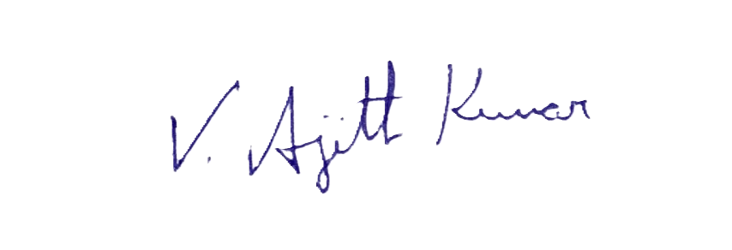For Shine Craft Technologies.,

(Ajith Kumar V)
Founder and COO

